Lab 8 Manual

Module 6: Forms and Validation in Blazor - Lab Manual
Objective:
The goal of this lab is to teach students how to:
- Build forms in Blazor.
- Implement validation using Data Annotations.
- Implement custom validation logic using custom validation attributes.
- Introduction to Forms in Blazor
Blazor provides a powerful mechanism for creating forms using the EditForm component. This component allows you to handle form submissions, perform validation, and bind form fields to model properties.
- Create a New Blazor Application
- Open Visual Studio and create a new project.
- Select Blazor WebAssembly App.
- Name the project BlazorFormsValidation.
- Create the User Model
- Create a class named Users.cs.
- Add the following code to define the Users class, which will include validation attributes:
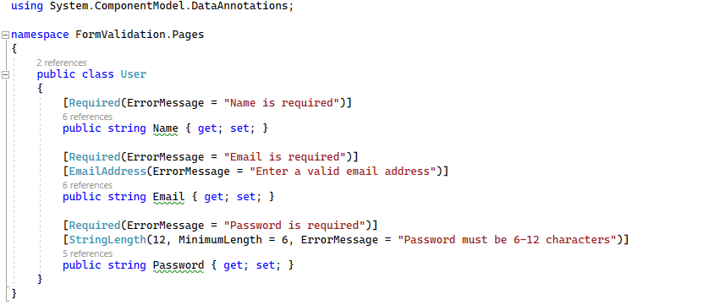
- Create the Registration Form (Register.razor)
- In the Pages folder, create a new Razor component named Register.razor.
- Add the following code to the Register.razor page to create the registration form and implement form validation:

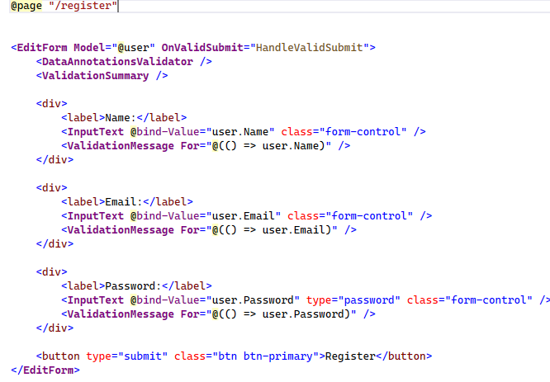
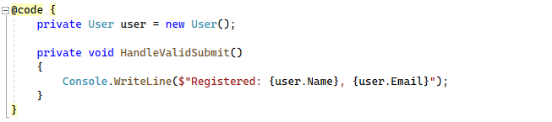
- Testing the Form
- Run your application and navigate to /register.
- Try submitting the form with the following cases:
  - Name: Leave it empty to see the "Name is required" error.
  - Email: Enter an invalid email address to see the "Enter a valid email" error.
  - Password: Enter different passwords less 6 characters

Custom Form Validation in Blazor
In Blazor, form validation is a crucial part of ensuring that the data submitted by users meets the expected format and rules. While Blazor provides built-in support for validation using Data Annotations, you can also implement custom validation logic using custom attributes or by implementing the IValidatableObject interface.
1. Custom Form Validation:
Custom validation is necessary when built-in validation (like Required, StringLength, etc.) does not meet the specific needs of your application. With custom validation, you can create rules that are unique to your application's logic.
Key Concepts in Custom Validation:
- Custom Validation Attribute: A custom validation attribute can be created by inheriting from the ValidationAttribute class. This allows you to define specific validation logic for a single field.
- IValidatableObject Interface: The IValidatableObject interface is an alternative way to implement custom validation logic. It is typically used when validation logic involves multiple properties within the same class (e.g., matching passwords, validating a combination of fields).

Example of Custom Validation using ValidationAttribute:

Task : Preventing a Username of "admin"
You want to prevent a user from selecting "admin" as a username.
Custom Attribute: NotAdminAttribute This custom validation attribute checks whether the username is set to "admin", and if so, it returns a validation error.
Code example
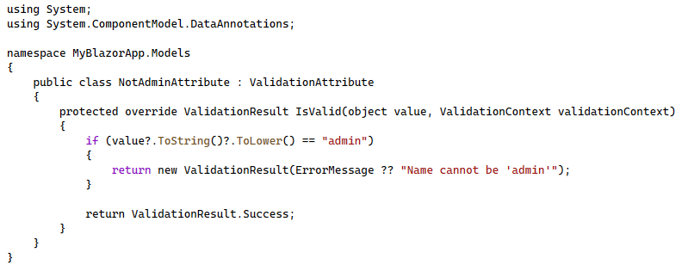
Usage in the User Model:
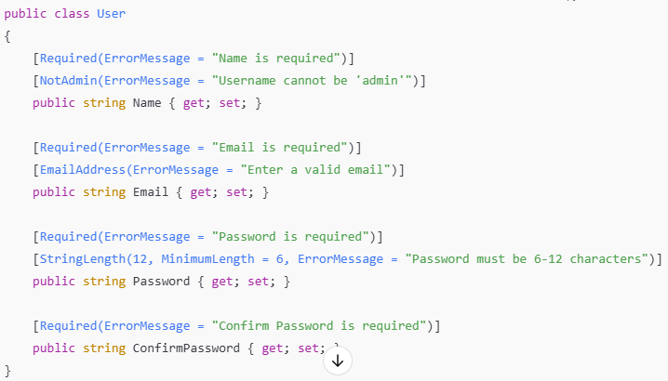

Explanation:
- Custom Validation Logic (NotAdminAttribute): This checks whether the username is "admin". If it is, the validation fails with a message: "Username cannot be 'admin'".
- Usage in the User Model: The Name property is now validated by both the Required and NotAdmin attributes.
Example of Custom Validation using IValidatableObject:
If validation depends on multiple fields, such as checking if the Password and ConfirmPassword match, you can use the IValidatableObject interface. This interface allows you to perform complex validations that involve more than one property.

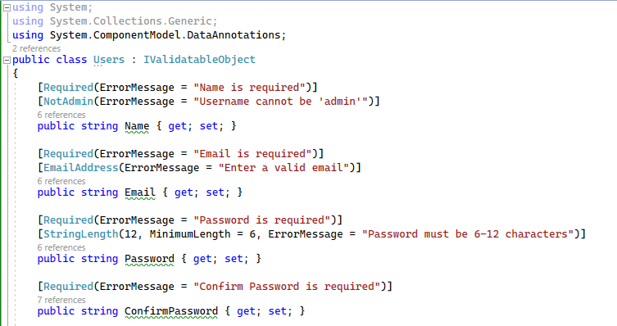
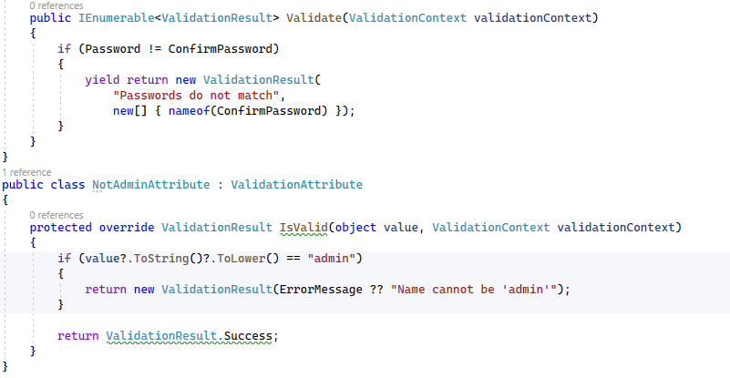
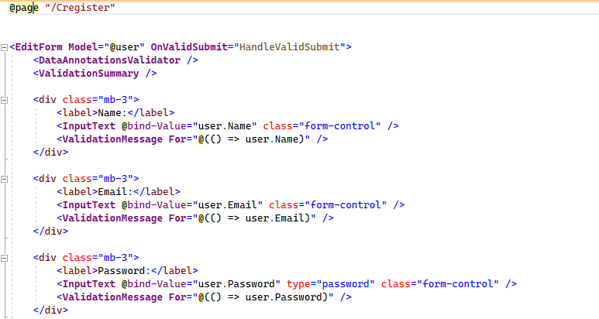
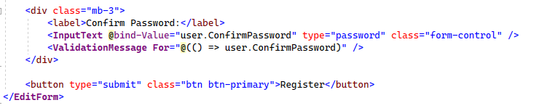
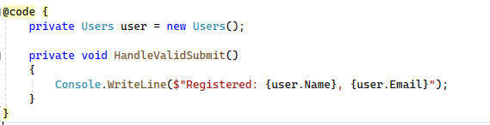

- IValidatableObject Interface: We implement this interface in the User class, and within the Validate method, we check if the Password and ConfirmPassword properties match. If they do not, we return a validation error message.
- Validation Result: The yield return statement is used to return the validation error, which will be displayed in the UI.

Practice Tasks
Here are a few tasks for students to practice custom form validation in Blazor.
Task 1: Prevent Reserved Words for Username
- Modify the custom validation to prevent users from registering with certain reserved usernames such as "admin", "root", or "superuser".
Task 2: Validate Phone Number Format
- Create a new PhoneNumberAttribute that checks if a phone number follows a specific format (e.g., (XXX) XXX-XXXX).
Task 3: Implement Age Validation
- Create a new custom validation that checks if the user’s age is between 18 and 120 years old. If it is not, return a validation error.
Task 4: Custom Validation for Complex Passwords
- Implement a custom validation for the Password field that enforces a password policy (e.g., must contain at least one uppercase letter, one number, and one special character).

